random password generator is software program or hardware device that takes input from

a random or pseudo-random number generator and automatically generates a password. Random

passwords can be generated manually, using simple sources of randomness such as dice or coins, or

they can be generated using a computer.

Speaking regarding the system, the user can create a random password according to various sizes. It

additionally presents with an aesthetic color-coded system which indicates the stamina of the

password, beginning from Very Weak to Superb password strength. After creating a random

password, the system presents it in the clipboard where the user can copy and paste easily.

This GUI based Password Generator supplies the most basic method for generating a solid

password for the individuals. In short, this job just concentrates on producing arbitrary passwords.

In order to run the task, you must have set up Python, on your PC. This is a basic GUI Based system,

specially composed for the beginners. Password Generator in Python with source code is

complementary to download. Use for education purpose only! For the project demo, look at the

picture slider listed below.

A random password generator is software program or hardware device that takes input from

a random or pseudo-random number generator and automatically generates a password. Random

passwords can be generated manually, using simple sources of randomness such as dice or coins, or

they can be generated using a computer.

Speaking regarding the system, the user can create a random password according to various sizes. It

additionally presents with an aesthetic color-coded system which indicates the stamina of the

password, beginning from Very Weak to Superb password strength. After creating a random

password, the system presents it in the clipboard where the user can copy and paste easily.

This GUI based Password Generator supplies the most basic method for generating a solid

password for the individuals. In short, this job just concentrates on producing arbitrary passwords.

In order to run the task, you must have set up Python, on your PC. This is a basic GUI Based system,

specially composed for the beginners. Password Generator in Python with source code is

complementary to download. Use for education purpose only! For the project demo, look at the

picture slider listed below.

A random password generator is software program or hardware device that takes input from

a random or pseudo-random number generator and automatically generates a password. Random

passwords can be generated manually, using simple sources of randomness such as dice or coins, or

they can be generated using a computer.

Speaking regarding the system, the user can create a random password according to various sizes. It

additionally presents with an aesthetic color-coded system which indicates the stamina of the

passwo

**CHAPTER**

**INTRODUCTION**

Chatbot are simulations that can understand human language, process it, and interact back with humans while performing specific tasks. For example, a chatbot can be employed as a helpdesk executive. Joseph Weizenbaum created the first chatbot in 1966, named Eliza.

Chatbot is an AI chatbot that uses natural language processing to create humanlike conversational dialogue. The language model can respond to questions.

Chatbots can automate tasks performed frequently and at specific times. This gives employees time to focus on more important tasks and prevents customers from waiting to receive responses.

With growing technology, everything has relied on data and securing these data is the main

concern. Passwords are meant to keep the data safe that we upload on the Internet.

An easy password can be hacked easily and all the personal information can be misused. In order

to prevent such things and keep the data safe, it is quite necessary to keep our passwords very

strong.

A password generator is a software application device that creates arbitrary or tailored passwords for

individuals. It assists individuals to produce more powerful passwords that offer greater protection

for a provided sort of access. Some password generators are merely random password generators.

These programs produce complex/strong passwords with mixes of numbers, uppercase and also

lowercase letters, and also unique personalities such as dental braces, asterisks, slashes, and so on.

It is a tool that generates passwords based on the given guidelines that you set to create an

unpredictable strong password for your accounts

**CHAPTER 2**

**OBJECTIVES**

Chatbots allow businesses to connect with customers in a personal way without the expense of human representatives. For example, many of the questions or issues customers have are common and easily answered. That's why companies create FAQs and troubleshooting guides.

**CHAPTER 3**

**LANGUAGE SPECIFICATION**

**3.1 Python?**

Python is a popular programming language. It was created by Guido van Rossum, and released in 1991. Python is one of the most popular languages for machine learning and has several powerful machine learning libraries, including TensorFlow and scikit-learn.

**3.2 JavaScript?**

JS stands for JavaScript. It is a text-based, lightweight, cross-platform, and interpreted scripting programming language.

This language is very popular for developing web pages.

It can be used both on the client-side and server-side.

JS is a programming language that is one of the core technologies of the World Wide Web, alongside HTML and CSS.

**3.3 CSS?**

CSS is the acronym of “Cascading Style Sheets”. CSS is a computer language for laying out and structuring web pages (HTML or XML). This language contains coding elements and is composed of these “cascading style sheets” which are equally called CSS files (. css).

With CSS, you can control the color, font, the size of text, the spacing between elements, how elements are positioned and laid out, what background images or background colors are to be used, different displays for different devices and screen sizes, and much more!

**3.4 JSON?**

JavaScript Object Notation (JSON) is a standard text-based format for representing structured data based on JavaScript object syntax. It is commonly used for transmitting data in web applications (e.g., sending some data from the server to the client, so it can be displayed on a web page, or vice versa).JSON stores data and the data can be easily accessed using key words.

**3.5 NLTK?**

The Natural Language Toolkit (NLTK) is a platform used for building Python programs that work with human language data for applying in statistical natural language processing (NLP). It contains text processing libraries for tokenization, parsing, classification, stemming, tagging and semantic reasoning.

**3.6 PyTorch?**

PyTorch is a fully featured framework for building deep learning models, which is a type of machine learning that's commonly used in applications like image recognition and language processing. Written in Python, it's relatively easy for most machine learning developers to learn and use.

**CHAPTER 4**

**SYSTEM SPECIFICATION**

**4.1 SOFTWARE REQUIREMENTS:**

Operating system: Windows 7 to 11

Language: Python,Html,Javascript,Css

**4.2 HARDWARE REQUIREMENTS:**

Processor: Intel core i5 to i7 and 8 Octa

Ram: 32GB

System type: 64bit Operating system

Hard disk: 500GB

**CHAPTER 5**

**IMPLEMENTATION**

* **HTML**

<!DOCTYPE html>

<html lang="en">

<link rel="stylesheet" href="style.css">

<head>

<meta charset="UTF-8">

<title>Chatbot</title>

</head>

<body>

<div class="container">

<canvas id="canvas"></canvas>

<div class="chatbox">

<div class="chatbox__support">

<div class="chatbox__header">

<div class="chatbox__image--header">

<img src="https://img.icons8.com/color/48/000000/circled-user-female-skin-type-5--v1.png" alt="image">

</div>

<div class="chatbox__content--header">

<h4 class="chatbox__heading--header">Chat support</h4>

<p class="chatbox__description--header">Hi. My name is ENO. How can I help you?</p>

</div>

</div>

<div class="chatbox__messages">

<div></div>

</div>

<div class="chatbox__footer">

<input type="text" placeholder="Write a message...">

<button class="chatbox__send--footer send__button">Send</button>

</div>

</div>

<div class="chatbox__button">

<button><img src="./images/chatbox-icon.svg" /></button>

</div>

</div>

</div>

<script src="app.js"></script>

<script src="main.js"></script>

</body>

</html>

* **PYTHON**

import numpy as np

import random

import json

import torch

import torch.nn as nn

from torch.utils.data import Dataset, DataLoader

from nltk_utils import bag_of_words, tokenize, stem

from model import NeuralNet

with open('intents.json', 'r') as f:

intents = json.load(f)

all_words = []

tags = []

xy = []

# loop through each sentence in our intents patterns

for intent in intents['intents']:

tag = intent['tag']

# add to tag list

tags.append(tag)

for pattern in intent['patterns']:

# tokenize each word in the sentence

w = tokenize(pattern)

# add to our words list

all_words.extend(w)

# add to xy pair

xy.append((w, tag))

# stem and lower each word

ignore_words = ['?', '.', '!']

all_words = [stem(w) for w in all_words if w not in ignore_words]

# remove duplicates and sort

all_words = sorted(set(all_words))

tags = sorted(set(tags))

print(len(xy), "patterns")

print(len(tags), "tags:", tags)

print(len(all_words), "unique stemmed words:", all_words)

# create training data

X_train = []

y_train = []

for (pattern_sentence, tag) in xy:

# X: bag of words for each pattern_sentence

bag = bag_of_words(pattern_sentence, all_words)

X_train.append(bag)

# y: PyTorch CrossEntropyLoss needs only class labels, not one-hot

label = tags.index(tag)

y_train.append(label)

X_train = np.array(X_train)

y_train = np.array(y_train)

# Hyper-parameters

num_epochs = 1000

batch_size = 8

learning_rate = 0.001

input_size = len(X_train[0])

hidden_size = 8

output_size = len(tags)

print(input_size, output_size)

class ChatDataset(Dataset):

def __init__(self):

self.n_samples = len(X_train)

self.x_data = X_train

self.y_data = y_train

# support indexing such that dataset[i] can be used to get i-th sample

def __getitem__(self, index):

return self.x_data[index], self.y_data[index]

# we can call len(dataset) to return the size

def __len__(self):

return self.n_samples

dataset = ChatDataset()

train_loader = DataLoader(dataset=dataset,

batch_size=batch_size,

shuffle=True,

num_workers=0)

device = torch.device('cuda' if torch.cuda.is_available() else 'cpu')

model = NeuralNet(input_size, hidden_size, output_size).to(device)

# Loss and optimizer

criterion = nn.CrossEntropyLoss()

optimizer = torch.optim.Adam(model.parameters(), lr=learning_rate)

# Train the model

for epoch in range(num_epochs):

for (words, labels) in train_loader:

words = words.to(device)

labels = labels.to(dtype=torch.long).to(device)

# Forward pass

outputs = model(words)

# if y would be one-hot, we must apply

# labels = torch.max(labels, 1)[1]

loss = criterion(outputs, labels)

# Backward and optimize

optimizer.zero_grad()

loss.backward()

optimizer.step()

if (epoch+1) % 100 == 0:

print (f'Epoch [{epoch+1}/{num_epochs}], Loss: {loss.item():.4f}')

print(f'final loss: {loss.item():.4f}')

data = {

"model_state": model.state_dict(),

"input_size": input_size,

"hidden_size": hidden_size,

"output_size": output_size,

"all_words": all_words,

"tags": tags

}

FILE = "data.pth"

torch.save(data, FILE)

print(f'training complete. file saved to {FILE}')

* **JAVASCRIPT**

class Chatbox {

constructor() {

this.args = {

openButton: document.querySelector('.chatbox__button'),

chatBox: document.querySelector('.chatbox__support'),

sendButton: document.querySelector('.send__button')

}

this.state = false;

this.messages = [];

}

display() {

const {openButton, chatBox, sendButton} = this.args;

openButton.addEventListener('click', () => this.toggleState(chatBox))

sendButton.addEventListener('click', () => this.onSendButton(chatBox))

const node = chatBox.querySelector('input');

node.addEventListener("keyup", ({key}) => {

if (key === "Enter") {

this.onSendButton(chatBox)

}

})

}

toggleState(chatbox) {

this.state = !this.state;

// show or hides the box

if(this.state) {

chatbox.classList.add('chatbox--active')

} else {

chatbox.classList.remove('chatbox--active')

}

}

onSendButton(chatbox) {

var textField = chatbox.querySelector('input');

let text1 = textField.value

if (text1 === "") {

return;

}

let msg1 = { name: "User", message: text1 }

this.messages.push(msg1);

fetch($SCRIPT_ROOT + 'predict', {

method: 'POST',

body: JSON.stringify({ message: text1 }),

mode: 'cors',

headers: {

'Content-Type': 'application/json'

},

})

.then(r => r.json())

.then(r => {

let msg2 = { name: "Sam", message: r.answer };

this.messages.push(msg2);

this.updateChatText(chatbox)

textField.value = ''

}).catch((error) => {

console.error('Error:', error);

this.updateChatText(chatbox)

textField.value = ''

});

}

updateChatText(chatbox) {

var html = '';

this.messages.slice().reverse().forEach(function(item, index) {

if (item.name === "Sam")

{

html += '<div class="messages__item--visitor">' + item.message + '</div>'

}

else

{

html += '<div class="messages__item--operator">' + item.message + '</div>'

}

});

const chatmessage = chatbox.querySelector('.chatbox__messages');

chatmessage.innerHTML = html;

}

}

const chatbox = new Chatbox();

chatbox

**RESULT**

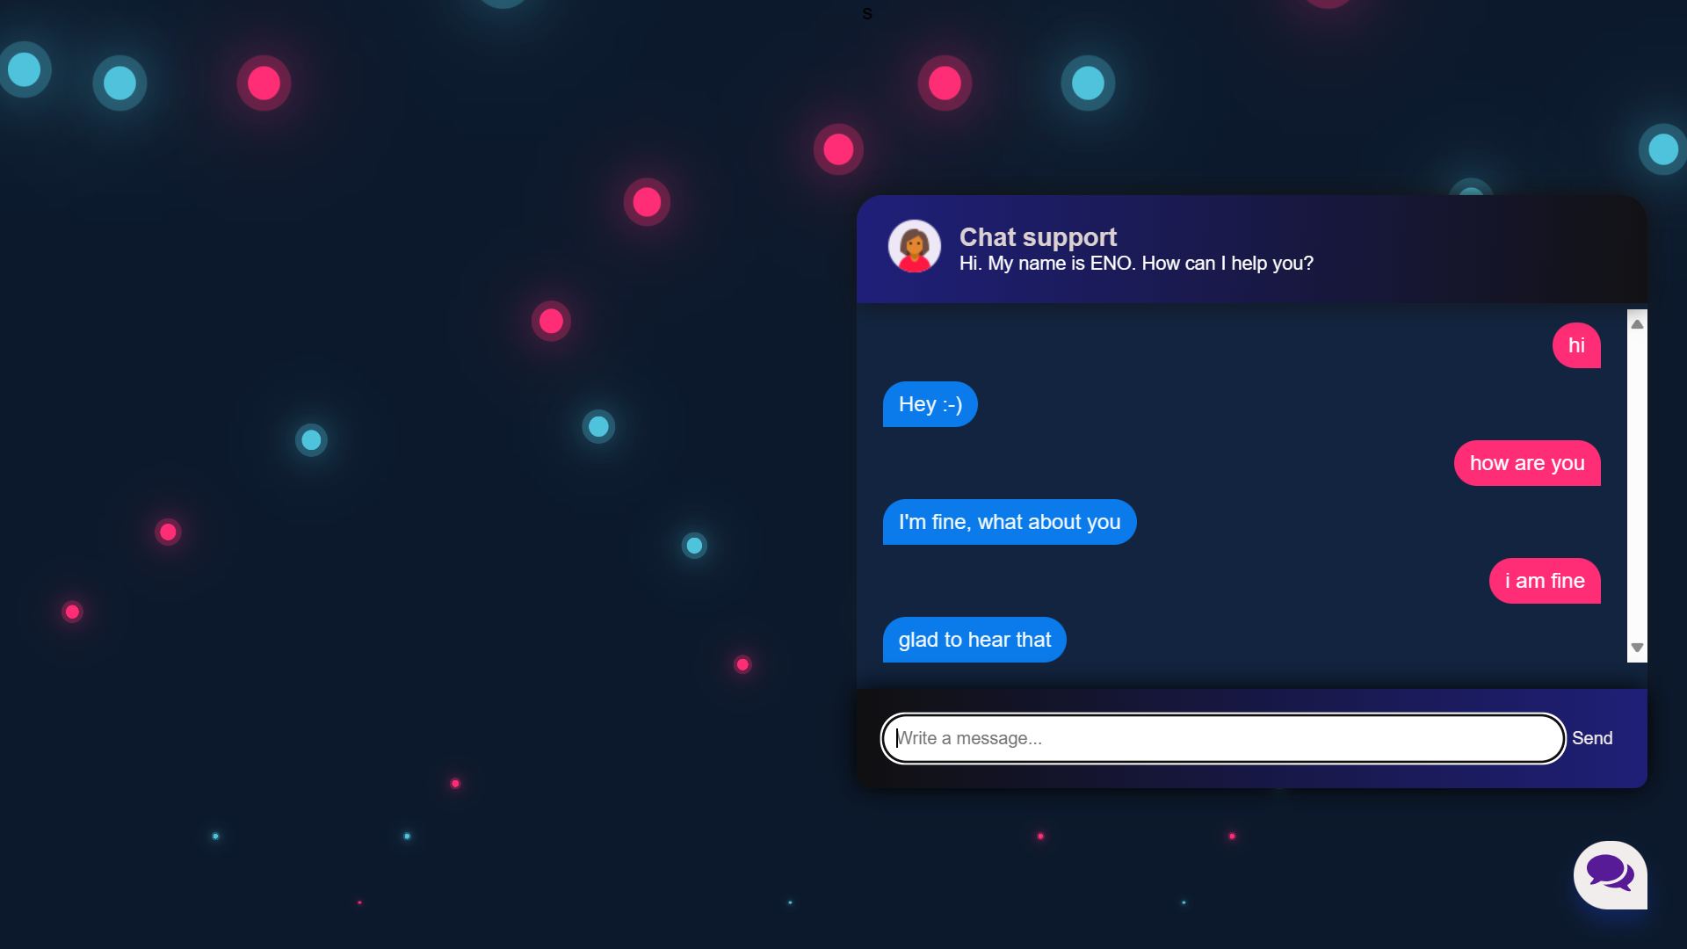

**CONCLUSION**

A chatbot is one of the simple ways to transport data from a computer without having to think for proper keywords to look up in a search or browse several web pages to collect information; users can easily type their query in natural language and retrieve information.*A random password generator is software program or hardware device that takes input from*

*a random or pseudo-random number generator and automatically generates a password. Random*

*passwords can be generated manually, using simple sources of randomness such as dice or coins, or*

*they can be generated using a computer.*

*Speaking regarding the system, the user can create a random password according to various sizes. It*

*additionally presents with an aesthetic color-coded system which indicates the stamina of the*

*password, beginning from Very Weak to Superb password strength. After creating a random*

*password, the system presents it in the clipboard where the user can copy and paste easily.*

*This GUI based Password Generator supplies the most basic method for generating a solid*

*password for the individuals. In short, this job just concentrates on producing arbitrary passwords.*

*In order to run the task, you must have set up Python, on your PC. This is a basic GUI Based system,*

*specially composed for the beginners. Password Generator in Python with source code is*

*complementary to download. Use for education purpose only! For the project demo, look at the*

*picture slider listed below.*

A chatbot is one of the simple ways to transport data from a computer without having to think for proper keywords to look up in a search or browse several web pages to collect information; users can easily type their query in natural language and retrieve information.

**REFERENCES**

1.https://www.google.com

2.https://www.geeksforgeeks.org

3.https://www.youtube.com